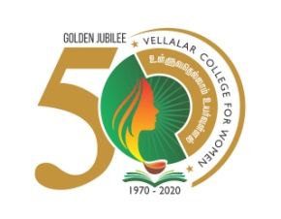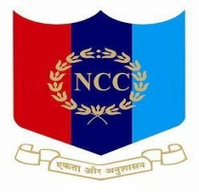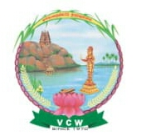

**VELLALAR COLLEGE FOR WOMEN (AUTONOMOUS), ERODE -12.**

**College with Potential for Excellence**

**(Reaccredited with ‘A’ Grade by NAAC & Affiliated to Bharathiar University, Coimbatore)**

**National Cadet Corps**

**15 Tamil Nadu Battalion NCC**

**20th YEAR ANNIVERSARY CELEBRATION OF KARGIL VIJAY DIWAS**

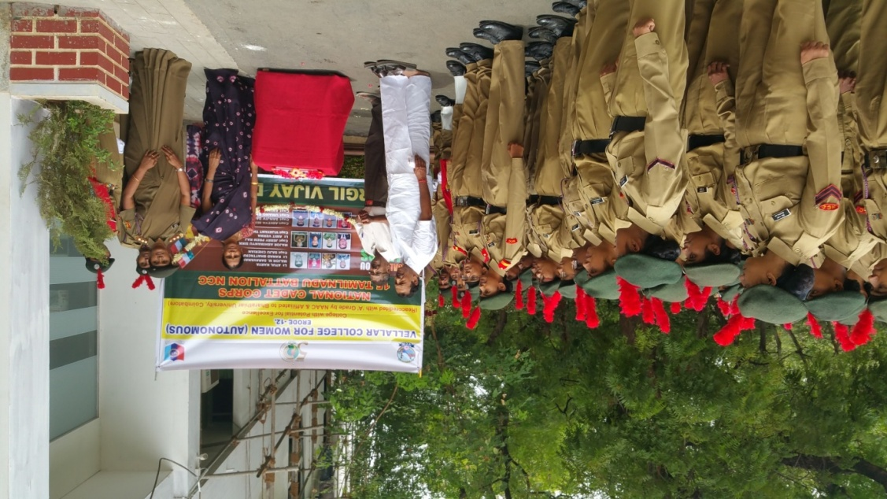

**Venue:** Conference Hall, Vellalar College for Women.

**Date :** 26.07.2019

**Time :** 4.00 pm

**Program Objective:**

To create awareness among the youth and public about the Kargil Vijay Diwas.

**VELLALAR COLLEGE FOR WOMEN (AUTONOMOUS), ERODE-12.**

**20th YEAR ANNIVERSARY CELEBRATION OF KARGIL VIJAY DIWAS**

**REPORT**

Cadets from Vellalar College for Women had actively took part in the 20th anniversary celebration of Kargil Vijay Diwas. This program was guided by Captain Dr.N.Kavitha, Associate NCC Officer. This program was organized on 26.07.2019 from 4.00 pm to 5.30 pm in conference hall . It was inaugurated by Thiru.S.D.ChandraSekar, Secretary, Vellalar Educational Trust, Erode, Thiru.C.Jayakumar, Executive member, Dr.N.Maragatham, Principal of Vellalar College for Women, Faculty members and the Non - Teaching staff members. In this program, the inspirational speech was given by our Cadets. The power point presentation and motivational videos were also presented . **Kargil Vijay Diwas** iscelebrated on 26 July every year in honour of the Kargil War's Heroes . On this day in 1999 India successfully took command of the high outposts. This war was fought for more than 60 days and ended on 26 July 1999, when the Pakistani army took advantage of the melting snow and betraying the bilateral understanding of both the nations that the post would remain unattended during the winter season took command of the high outposts of India. The Kargil war resulted in loss of life on both the sides and was ended when India regained control over the post and ejected the Pakistani Army out of the territory. It is a symbol of India’s proud, valor and stead fast leadership. The country is proud of the heroes of India, who dedicated to protecting the mother land. Various programmes are also organized all over the country to commemorate the contributions of the armed forces.

**I REGRET I HAVE ONLY ONE LIFE TO GIVE FOR MY COUNTRY**

**Inaugurated by our Chief Guests and Faculty Members :**

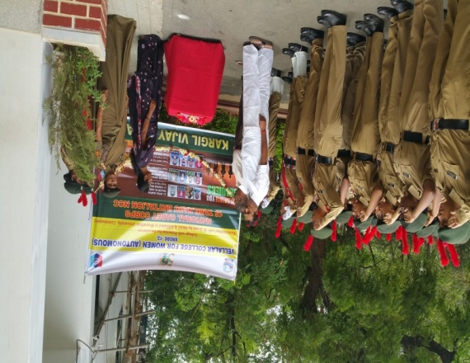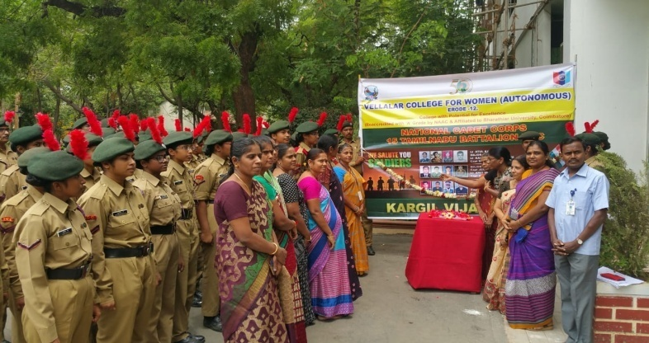

**Speech given by our Cadets :**

**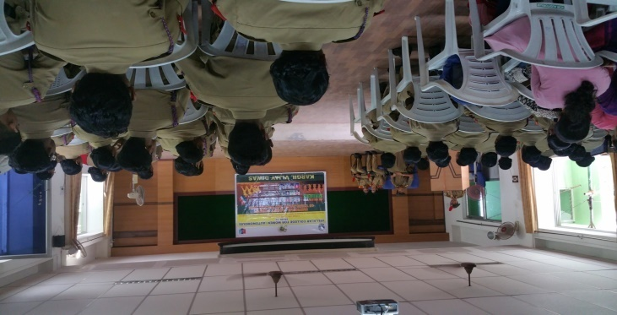  
Power point and video presented by our cadets :**

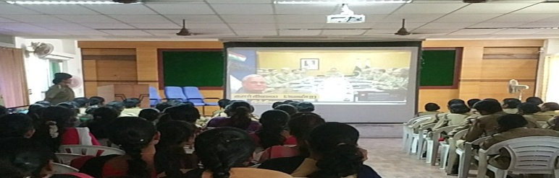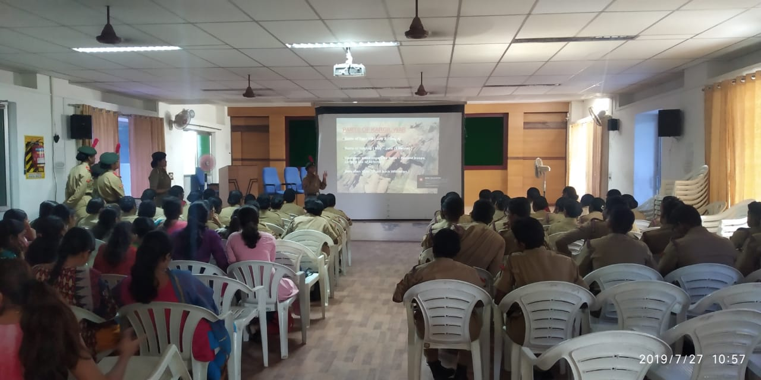

**NATURE WILL SALUTE YOU**